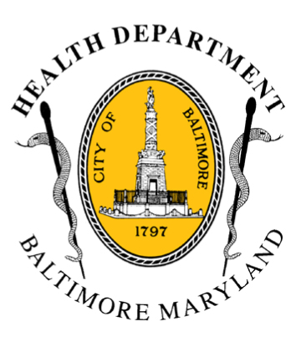
BCHD PRESS RELEASE
Baltimore City Health Department
1001 E. Fayette Street • Baltimore, Maryland 21202
Stephanie Rawlings-Blake, Mayor / Leana Wen, M.D., Commissioner of Health

FOR IMMEDIATE RELEASE

Media Contact: Michael Schwartzberg, PIO
O: (443) 984-2623 C: (443) 462-7939 E: michael.schwartzberg@baltimorecity.gov
Baltimore City Health Commissioner Calls Increasing Cost Of Naloxone a “Public Health Crisis”; Issues Support For Inquiry Launched By Representative Cummings

BALTIMORE, MD (March 2, 2015) – Baltimore City Health Commissioner Leana Wen, M.D. today applauded two congressional leaders, including Maryland Representative Elijah E. Cummings, for their inquiry into increasing prices charged by one manufacturer of naloxone. Increasing the availability of naloxone, a medication used to safely reverse opioid overdoses, is a key component of Baltimore’s strategy to combat overdose deaths.

Rep. Cummings, ranking member of the House Committee on Oversight and Government Reform, and Senator Bernard Sanders, ranking member of the Subcommittee on Primary Health and Retirement Security on the Senate Committee on Health, Education, Labor and Pensions, today announced they had co-signed a letter sent to the chief executive officer of Amphastar Pharmaceuticals requesting information about the increasing prices the company has been charging for naloxone.

The cost for BCHD to purchase intranasal doses of naloxone has more than doubled in less than a year. In May 2014, a 10-dose pack cost $193, while today the same amount costs $414.

“Naloxone is safe and effective, and is a critical tool to prevent people from dying of opioid overdoses,” said Dr. Wen, who also serves as chair of the board for Behavioral Health System Baltimore. “Baltimore City has limited funds. The rapidly rising cost of naloxone is a public health crisis.”

There were 246 deaths related to drugs and alcohol in Baltimore City in 2013, with 150 of those involving heroin and 86 involving prescription opioids. In 2014, Baltimore experienced 226 drug and alcohol related deaths between January and September, 143 of which were heroin related and 47 involved prescription opioids. More than one substance may be involved in an overdose death.​

- more-

2-2-2

Baltimore’s Heroin Treatment and Prevention Task Force, established last year by Mayor Stephanie Rawlings-Blake, estimates that Baltimore has 19,000 people who have used heroin in the last year.

Since 2004, the Baltimore City Health Department’s Staying Alive Drug Overdose Prevention and Response Program has taught more than 12,000 injection drug users, drug treatment clients and providers, prison inmates, and corrections officers about how to prevent drug overdoses. More than 230 reversals (lives saved) have been documented.

The Health Department is overseeing overdose prevention efforts in the city which include Staying Alive and community-level trainings by Behavioral Health System Baltimore on how to prevent and respond to overdose emergencies.

###

